Name:

Address:

Edgar Renee Aesthetic Education & Consulting Group

2692 Sawbury Blvd. Columbus Ohio 43235

[education@edgarenee.com](mailto:Edgarenee@gmail.com)

www.edgarenee.com

(614)470- 4415

Monday-Sunday 7a-7p



Edgar Renee' Aesthetic Education & Consulting Group offers advanced esthetics hands-on training and lectures on advanced aesthetic topics, medical

It is our goal to elevate the esthetics industry to a whole new level by raising the bar when it comes to education. We will provide you ​with the most advanced high-quality training that you can receive. Our programs are taught by some of the most respected and knowledgeable educators in the industry and are focused on enabling students to achieve success. Simply take courses to quickly enhance your practice. Our courses are open to any licensed estheticians, cosmetologist and manicurists, as well as esthetician and cosmetology students who are currently enrolled in state board approved schools.

Our specialties are salon, spa & beauty business education and consulting. We aid with: startups; protocols, procedures, and polices; professional education through C. E. classes State Board preparation, Notary services, sales big box and boutique, retail programs and corporate wellness initiative programs, student mentorship, action plans and much more. Whether you are a spa owner, private practitioner, nurse or work as an esthetician in a salon or med-spa, we will arm you with the knowledge and tools you need to excel in aesthetics.

We Notarize State Board documents by appointment!

Call or visit [www.edgarenee.com](http://www.edgarenee.com) for class dates.

We have many dates available. We can arrange to come to your spa and offer in house education if you have at least 6 professionals interested in education/training.

Call to invest in you! 614-470-4415

www.edgarenee.com

***Invest in You!***

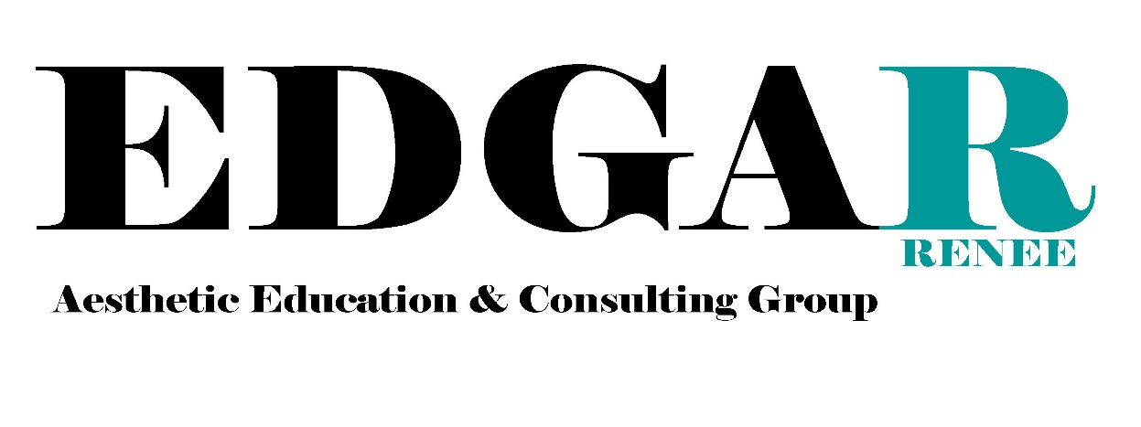

**Continuing Education (C.E.) Classes**

**Continuing Education**

Understanding Electrotherapy & Advanced Machines

Learn about direct, alternating currents as well as desincrustation, Iontophoresis and more…

 7 C.E. Hours $180

Instructor CE Training

If you are an instructor and you want to revamp your teaching style. This is a required course.

7 C.E. Hours $180

Microdermabrasion Techniques

Diamond tip Microdermabrasion techniques.

7 C.E. Hours $180.00

Advanced Chemical Peeling Methods

We will provide the skin care professional with knowledge of glycolic, salicylic, lactic acid and more.

7C.E. Hours $180

Accelerated Body Waxing

Learn bikini, Brazilian manzilian, as well as full body waxing techniques.

7 C.E. Hours $180

 Dermaplaning

A safe procedure for exfoliating the epidermis.

7C.E. Hours $380 class comes with starter kit

Acne Specialist

Learn to recognize different degrees of acne.

7 Hours C.E. Hour $210 Regular; class comes with starter kit.

Full Body Relaxation Massage

Learn a routine for your full body massage. Hands on.

7 C.E. Hour $180

Treating Darker Fitzpatrick’s

Learn how to treat diverse pigmentations as well as hyperpigmentation on the skin

7 C.E. Hours $180

Eyelash Specialist

By attending this course, you will learn how to apply extensions like a pro with no gimmicks from product manufacturers. Certificate & kit included

14 C.E. Hours 2 Day Class $1200

**Continuing Education**

Cosmetic Ingredient Knowledge

5 C.E. Hours $150

Dermaplaning

A safe procedure for exfoliating the epidermis.

1C.E. Hours $25 class comes with starter kit

Treating Darker Fitzpatrick’s

Learn how to treat diverse pigmentations as well as hyperpigmentation on the skin

1 C.E. Hours $25

2 Hour Ohio required Sanitation class

This course is the sanitation class that is required for your Ohio license.

2 C.E. Hour Class $50

**Continuing Education (Non C.E.) Classes**

Eyebrows

4 Hours $160 Kit included

Anti-cellulite

7 Hours $210​

Lymphatic Drainage

7Hours $210

Integumentary System

7 Hours$210

Micro-current for the Skin

7 Hours $210

Ear Piercing Certificate

2 Hours $100

Spa Manicuring & Pedicuring

7 Hours $210

Nail Enhancement Techniques

We will cover all acrylics systems

7 Hours $210

Business Boot-camp

7 Hours $ 210

Educator Training

7 Hours $210

**Courses**

Advanced clinical skin care

Learn in-depth and clinical skin care.

4-6-week course.

Every Thursday 9a-4p day

Every Thursday 5p-9p evenings

$1,750.00

  Holistic Skin Care

Learn Ayurveda treatments, global and ancient skin care treatments. Understand the value of natural verses synthetic skin care.

4-6-week course

Every Wednesday 9a-4p day

Every Wednesday 5p-9p evenings

$1,750.00

  Cosmetician

This is a cosmetologist to esthetician course by learning the fundamentals to the advanced aesthetics portion of your cosmetology license.

 6-10-week

Every Tuesday 9a-4p day

Every Tuesday 5p-9p evenings

$2,250.00

  Permanent Makeup

Class includes step-by-step instructions, hands-on-procedures, and demonstrations of permanent eyebrows, eyeliner, and lip liner. We will also cover topics on: health considerations, color selection, insurance coverage, consent forms, consultations, numbing with topical, communicating with clients, and procedure techniques.

5-day course

$2800

Micro-blading

Class includes step-by-step instructions, hands-on-procedures, and demonstrations of permanent eyebrows. We will also cover topics on: health considerations, color micro-blading client selection, insurance coverage, consent forms, consultations, numbing with a topical agent, communicating with clients, and procedure techniques.

2 Day course

$2200

*Micro blading & Permanent Makeup combination programs are available for $4500*